## NAME: AKACHI IKWU

## SUBJECT: SIT103

## STUDENT_ID: 221320482

* 1. ABOUT THE COMPANY

**God’s Knot Hospital** is a private clinic founded by Dr. Olowokere in the year 2014 with website address godsknothospital.com.ng. Its aim is to give low and affordable medical services to people. The hospital is fully equipped with modern surgical equipment, laboratory equipment and neonatal appliances. Their annual turn-over is over twelve million Naira (AUD32,000). It is located at New Eleyele Road,Ibadan,Oyo State, Nigeria*.*God’s Knot Specialist has no other branch in the country. The Hospital offers services like: Medical Surgery, Antenatal care, Laboratory services.

God’s Knot Specialist Hospital also has somesub sectionswhich include the Scan section, the med lab, radiology, the dispensary (mini pharmacy). These sub sections are headed by specialists. The hospital has approximately 32employees which include: Eight General physicians, Five gynecologists, Three pediatricians, three radiologists, Two urologists, nine nurses and two non-medical staff.

***The mission and vision of this clinic***:

To be an unrivaled health care provider of repute in Nigeria, offering the best standard of care to all, cutting across social and economic divide.

**Stakeholders**: Medical Director (MD), Consultant Anesthetist, Head Nursing Services (NHS), H.O.D Pharmacy, H.O.D Laboratory Services, H.O.D Accounts and H.O.D Health/Medical Records.

The hospital offers placement and training to student Nurses.

There are a few other clinicsin competition withGod’s Knot hospital. Here are to mention a few:

St Dominic Catholic Hospital: https//saintdominicch.org/

Vine Branch Medical Centre: https://vbmedicalcentre.com/

1.2 Business Scenario

God’s Knot Hospital has two buildings in one location. The main building is the where the reception, medical laboratory, scan section, dispensary is located while the other building is used forLaparoscopic Surgery.

When a new patient comes into the clinic, he/she must go to the reception desk tofill a personal information form where the patient will give information like Their names, mobile number, address etc. This information will be stored in the hospitals’ data base, and they are given a Clinic card containing their names and Identification Number. The patients are usually asked to wait for their turn to see a General practitioner (GP). After a GP sees a patient, a prescription is written by the GP which the GP hands over to the nurse who takes the prescription to the dispensary. The patient is now directed to the dispensary where they wait until their name is called, and he/she picks up their medicine.

Also, if the GP recommends an ultrasound for a patient, a nurse takes the Patient’s information to the radiologists whocalls in the patients one after the other when it’s their turn to perform an ultrasound scan on them. Also, if the GP recommends surgery, a date is fixed for the patient. For surgery however, the patients are required to make a deposit of at least half of the total amount charged for the surgery before the due date of the surgery and then pays the balance amount after the surgery has taken place.

Usually after a patient receives any service, their information is usually forwarded to the cost center where an invoice is generated and handed over to the patient who makes the payment over the counter and then receives a receipt. This Receipt will be used to generate the patient’s laboratory /scan resultwhen next the patient visits the GP for a follow up.

The owner of the clinic who is also the Medical Director (MD) is the only one who has the right to give any patient a discount which is usually filled into the patient’s record information folder.

All employees of this clinic are paid monthly via their bank accounts according to the number of hours they have worked each month. The employees also work on a rotating roster. Some of the employees are part time workers who also have jobs in other clinics while others are full time workers.

**Company review**

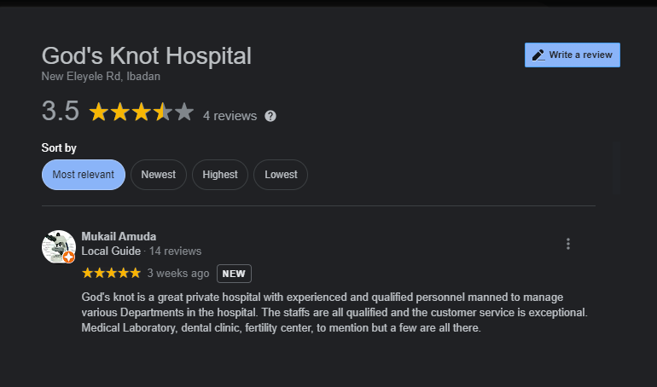

**Competitors review**

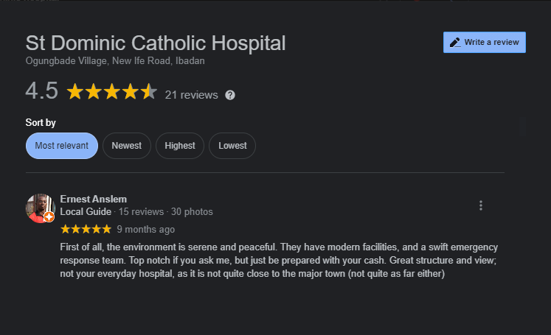

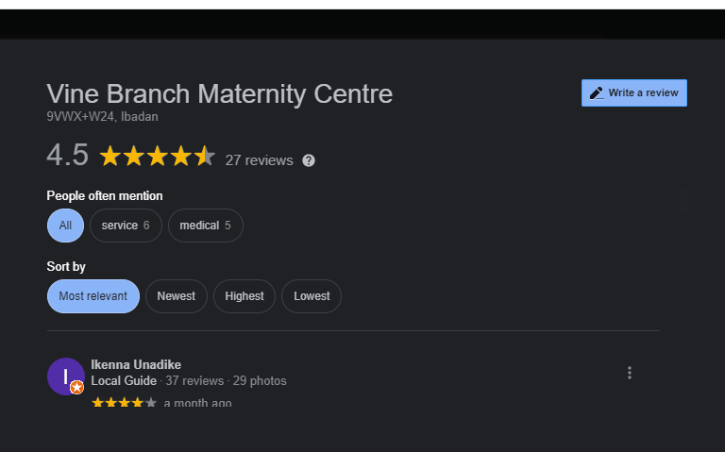

Vine Branch Maternity Centre is another good clinic in Ibadan, Oyo State, Nigeria owned by a Gynecologist named Dr. Adewale. When a patient opens a file (registration) thereby providing his/her information, the patient is given a clinic card and waits to be called for vital sign after which he/she is called to meet the GP. The employees are paid monthly via their bank accounts.

Business Rules ( Assumptions)

A GP can attend to many patients.

A patient is attended to by one Doctor.

When a patient’s GP is not available, a patient can assign another GP.

Some patients do not get Prescriptions after a consultation.

Medicines are supplied in the Dispensary section.

A patient has her/his main GP.

Two or more doctors are not allowed to prescribe drugs for a patient.

The Radiologist assistant (staff) takes the scan reports to their different patients’ doctors.

Patients pay at the account department.

Staffs are paid according to their job type by the account department.

Doctors are paid daily according to the number of patients they consult by the account department.

Doctors’ salaries are paid monthly through the account department.

Patients must make a bill payment either a consultation, dressing of wounds, surgical procedures etc.

Doctors are identified by their names.

* 1. Context level data flow diagram

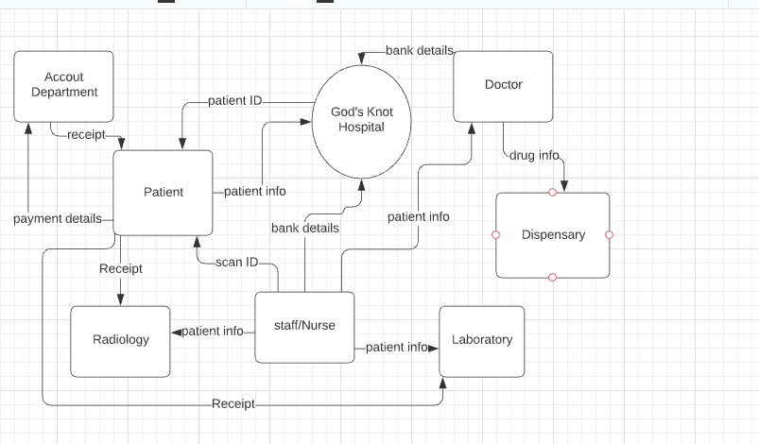

1.3b some input and output

**PATIENT FILE (input):** Patient’sname, Patient’sphone number, Patient’saddress, patient next of kin, and relationship with next of kin

**RECEIPT (output):** receipt Number, patient’sname, reasons for payment,amount paid,and date.

**CLINIC CARD (output):** clinic phone number, card number,patient name, and date.

**REFERENCE**

Africabz.com 2021, *St. Dominic Catholic Hospital,*reviewed 10 September 2021 <<https://ng.africabz.com/oyo/st-dominic-catholic-hospital-179829>>

Babymigo 2021, *The vine medical Centre*, Reviews, reviewed 10 September 2021<<https://babymigo.com/oyo/vine-branch-medical-centre>>

Facebook (n.d), *God’s knot Hospital*, accessed on12 September 2021<<https://m.facebook.com/pages/category/Health-Beauty/Gods-Knot-Hospital-Gosam-1482770165073736/>>.